How to Renew an Existing NOI (submit a reissuance application) in GEOS
Primary and Tertiary NOIs Only:
- Go to website: https://geos.epd.georgia.gov/GA/GEOS/Public/GovEnt/Shared/Pages/Main/Login.aspx
and log into your GEOS account.
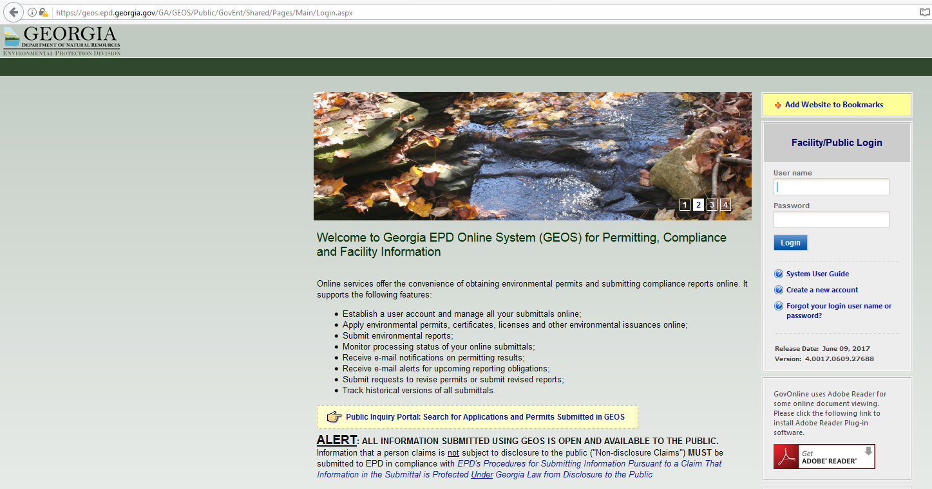

- You can see the NOI on the main screen (My Dashboard) or under the Manage Permits tab. Click the blue “Action” button.
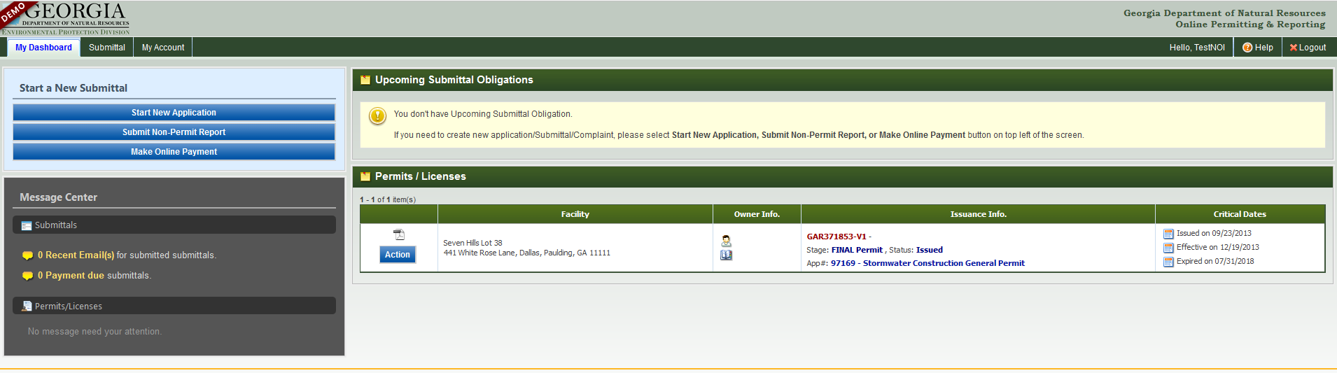

- Select the “Renewal” option on the pop-up screen and click the blue “Ok” button.
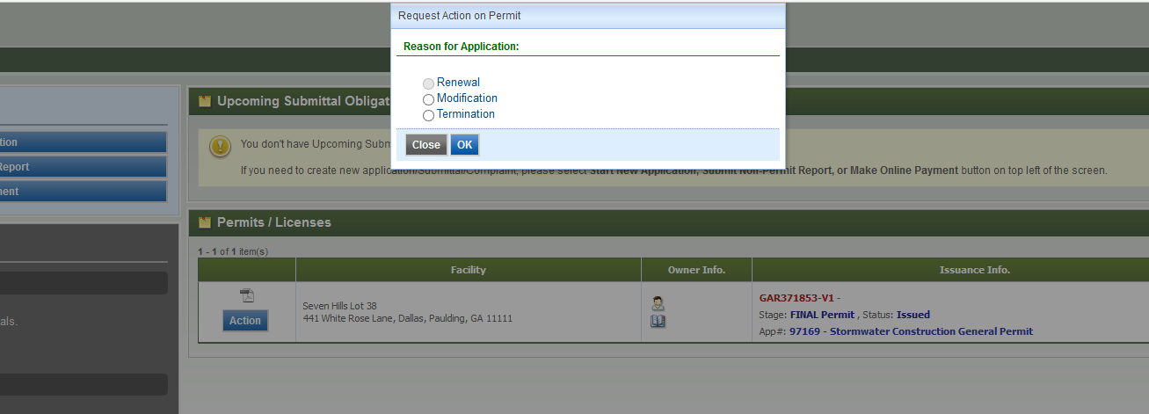

- The first page will show the type of NOI permit coverage that was submitted originally and cannot be changed. Click the blue “Next” button to continue.
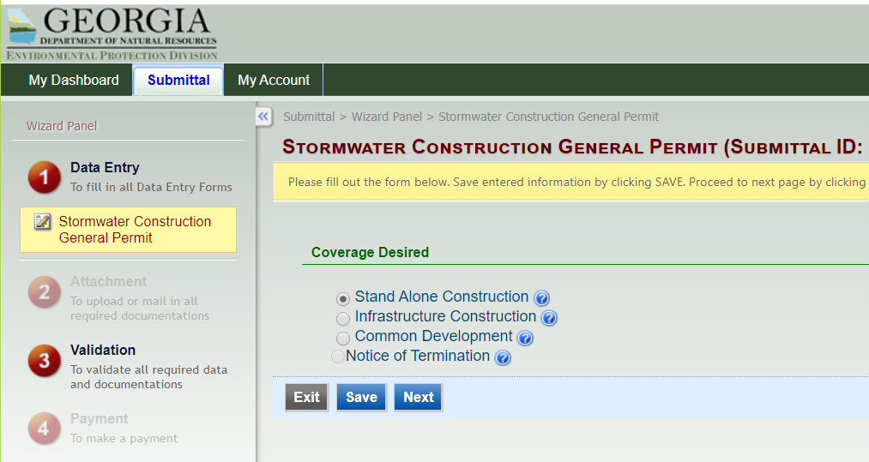

- The second page will be the NOI general information and cannot be changed. Review this page and click the blue “Next” button at the bottom of the page.
Note: If updates or corrections need to be made to the NOI, first get the Renewal NOI application submitted and approved, then a Modification NOI application can be submitted to make changes.
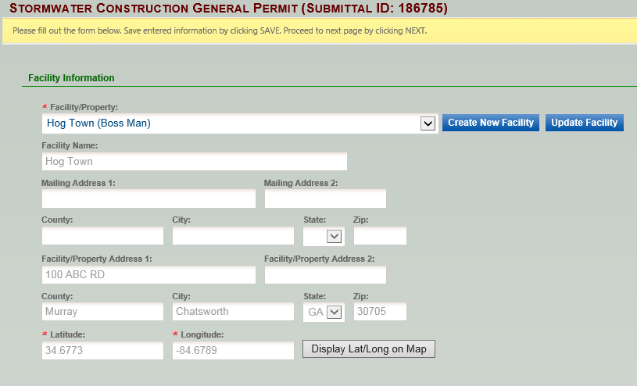

- The third page will be the attachments page. As long as all documents are already uploaded, you should be able to click the blue “Next” button.
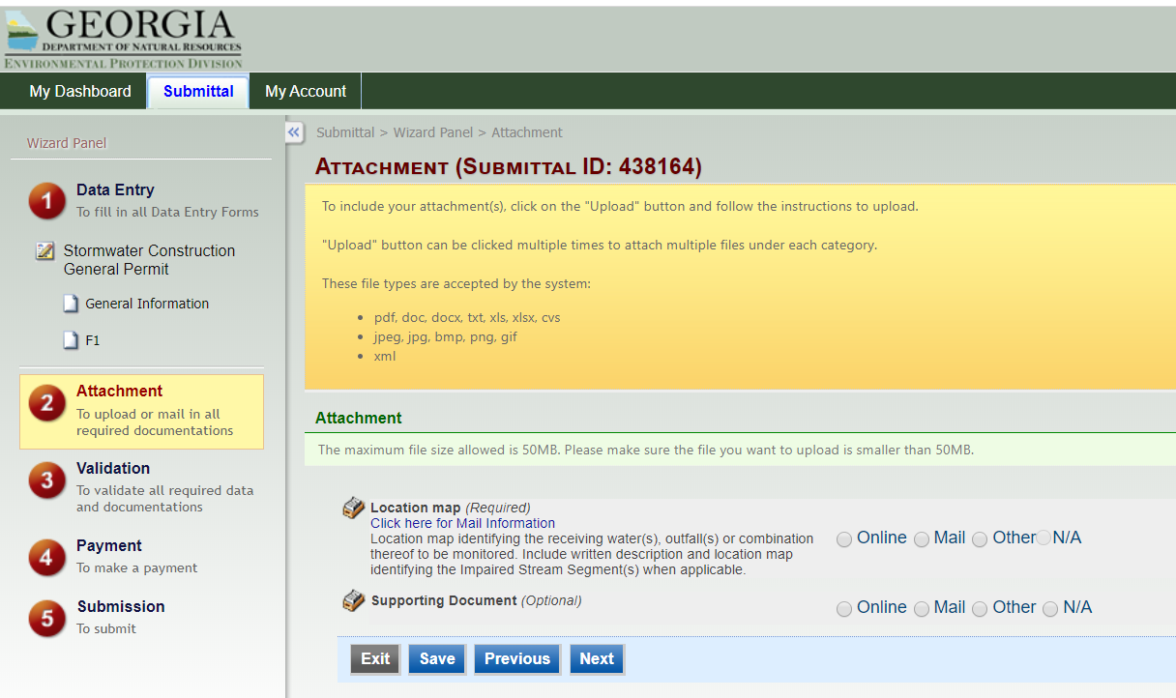
- The fourth page will be the validation page and you should see all green checks. Click the blue “Next” button.
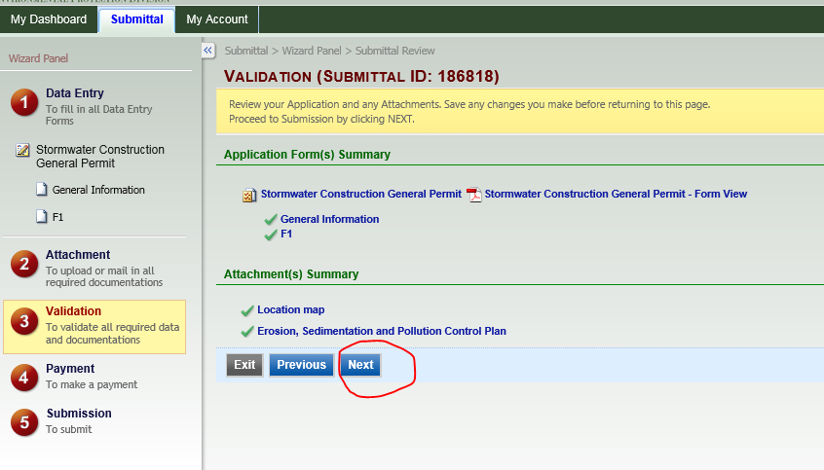

- If all of the NOI fees were previously paid, GEOS will skip the payment page and will go directly to the final page, the submission page. Check the authorization box and answer the security question. Then type in your 4-digit PIN number and click the blue “Submit” button.
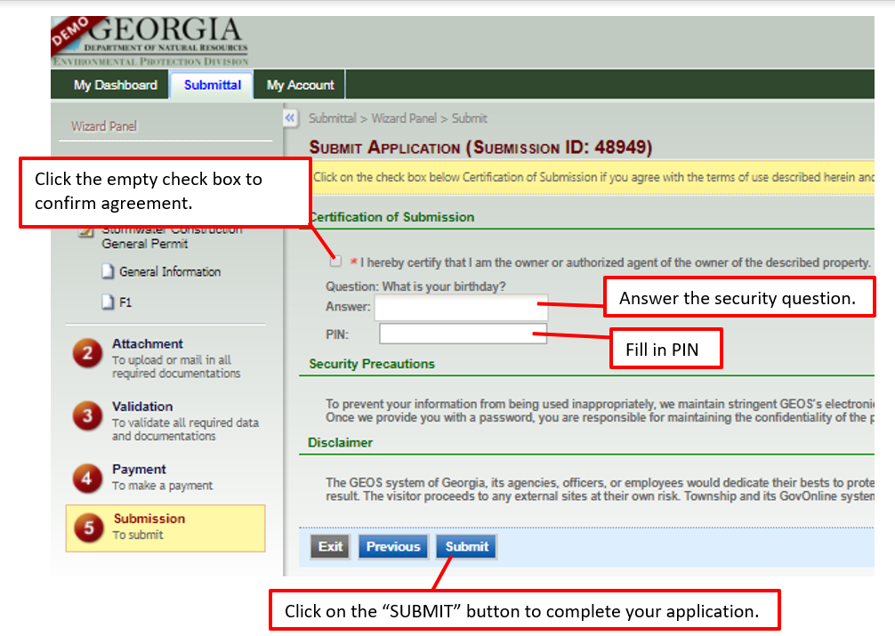
- Once you successfully submit your Renewal NOI application, you will receive a Submittal Receipt.
